Leasing or Buying Systems Project
Institution
Course
Name

Sources of Funding
For a business to start, it requires financing in order to start running so that it can, later on, become profitable. There are various sources of financing where an entrepreneur can look for start-up financing. However, there is always a need first to consider how much is required for the business to start running and at what point in time will the funding be required. Additionally, the financial needs of business will vary following the kind and size of the business (Dewar, 2011). For instance, this will be a tech company, and it is normally capital intensive, requires large amounts of capital. In this case, debt and equity will be the main source of finance.
Equity Financing
Equity financing involves exchanging a percentage of ownership of a company for a financial investment within the company. The resulting ownership stake which is brought about by the equity investment allows the investors to share the profits that are earned by the company (Dewar, 2011). Some of the sources in this category will involve;
Personal Savings
The first place that an investor looks for money is his or her savings. Personal resources might entail cash value insurance policies, real estate equity loans, and profit sharing and early retirement funds.
Venture Capital
Venture capital involves financing which comes from organizations or people in the business of investing in young and privately owned companies. They normally provide finance for the new start-up company in exchange for ownership (Dewar, 2011). However, venture capitals do not like taking part in the initial financing of a start-up business unless its management has got a proven track record. But, they prefer organizations that have already received significant funding from the pioneers.
Equity Offerings
Equity offerings involve the business selling some of its stocks directly to the public. Equity offering has the ability to raise a substantial amount of funds. The equity offerings might take different forms which include; initial public offerings and warrants.
Debt Financing
Debt financing takes the form of the investor borrowing from the creditors who in turn repay the borrowed money plus interest within a specified time. In this case, the company will only consider borrowing from commercial banks.
Financial risk for both the project and for the investors/financiers
The financial risks will be related to the businesses' use of financial leverage and debt financing. Financial risk will be considered as one of the high-priority risks in the business. Such risks take place due to market movements. Financial risks that will be involved within the project will involve market risk, credit risk, liquidity risk and operational risk (Finnerty, 2011).
Liquidity Risk
Liquidity risks arise when a business is not able to execute transactions. These risks can be classified as either asset liquidity risk or funding liquidity risk (Finnerty, 2011). Asset liquidity risk will arise when the business will not have sufficient buyers or will have insufficient sellers against sell orders.
Operational Risk
The operational risk might arise due to failures such as mismanagement or technical failures. Operational risk can further be divided into model and fraud risks. Fraud risk arises from a lack of control, whereas model risk results from the incorrect model application.
Credit Risk
Credit risk will arise when one of the involved parties fails to meet its obligations towards the other party. In this case, there might be risk whereby one of the parties involved in the agreement fails to make the payment while the other fulfills its obligations (Finnerty, 2011). For instance, the commercial banks might finance the project and may be the project might not turn out to be making the expected profits hence the business might fail in its obligation or repaying the borrowed cash plus the interest.
Market Risk
Market risk arises from the price movement within the industry of operation. There might be unfavorable movements in stock price, interest rates and much more. Thus, if such occurrences take place, the project might not perform as expected.
Any potential cost overruns or opportunities for cost reductions.
Many organizations work on tight margins. As a consequence, start-up business owners might look for ways through which the can reduce their operating costs without having sacrificed the quality of what they offer in the market (Kendrick, 2009). The opportunities for cost reductions that might be available for the company are;
Reduce Running Costs with Outsourcing
The company will outsource some of the activities that do not core with regard to their operation. For instance, the company is going to benefit from outsourcing its advertising and marketing. Many entrepreneurs normally find out that the amount of time that they spend on advertising and marketing does not correlate to the return on investment.
Telecommute to Lower Operation Costs
Nowadays, leasing office space, paying for the utilities and managing a physical working space such as an office can drain on the company's financial resources. Thus, the company will allow its employees to telecommute. With the rate of technological advancements experienced today, the difference between an employee being sited in an office and sitting at his or her home is almost indiscernible (Kendrick, 2009). This will save employees time and travelling expenses.
The funds that will be raised will be used in paying for expenses such as salary for the workers such as the web developers, software engineers, purchasing the computers, training, administration and maintenance expenses. The expenses are analyzed in the following table.
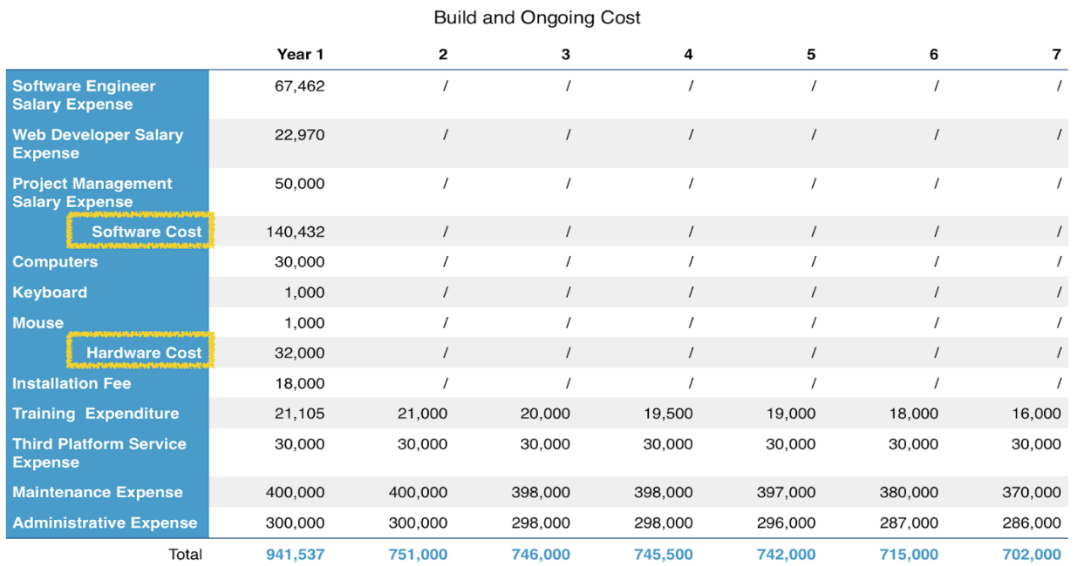

References
Dewar, J. (2011). International project finance: Law and practice. Oxford: Oxford University Press.
Finnerty, J. D. (2011). Project Financing: Asset-Based Financial Engineering. New York, NY: Wiley, J.
Kendrick, T. (2009). Identifying and managing project risk: Essential tools for failure-proofing your project. New York: AMACON.

